How to Render Your Blender Animation

- Save your file.
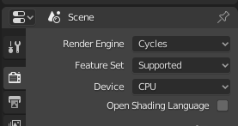
- In the RENDER PROPERTIES panel on
the right-hand side, make sure you
have the render engine you want selected.
Most likely it will by Cycles.

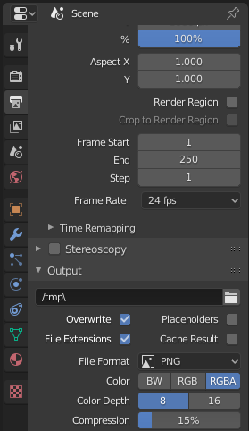
- In the OUTPUT PROPERTIES panel, in the Output section,
set the file format to PNG.

- Set the output location by clicking on the folder to the right
of the default (probably “/temp\”).
Create a new FOLDER as your render destination.
When you export as png files the output will be
single images of every frame in your animation
so there will be a lot of files that you’ll want to have
in one, separate location. Also set an appropriate name
for the files.

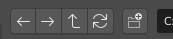
New folder icon

- In the RENDER menu at the top of the screen,
choose Render Animation. Wait.

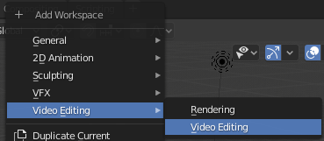

- When all the frames have been rendered, open the
VIDEO EDITING view by clicking on the “+” in the
far right-hand side of the menus

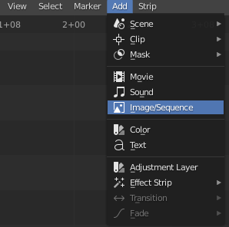
- From the ADD menu in the bottom panel,
Choose IMAGE/SEQUENCE.

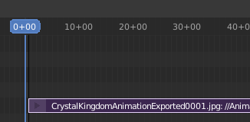
- Navigate to the folder where you rendered the images an select all the files by hitting ‘a’ on the keyboard. Click “Add Image Strip”. The images are imported as a single video strip. Align the strip so that it starts at 0 on the timeline.

Align to 0

- Finally, in the output properties panel, change your file format from png to ffmpeg video and designate where you want the final video to be output to. Then under the RENDER menu at the top of the screen, choose RENDER ANIMATION.

*** The advantage to doing your render in this way is that if something happens to the export on the first pass
(with PNGs) you can pick up and continue rendering from where you left off instead of having to start over completely again.

